Applicants: Dr. Chiranjit Sain, Dr. Amarjit Roy, Total Sheets 8
Nayan Nirban Baruah, Rituraj Boruah, Ujjal Ray Sheet 1 of 8

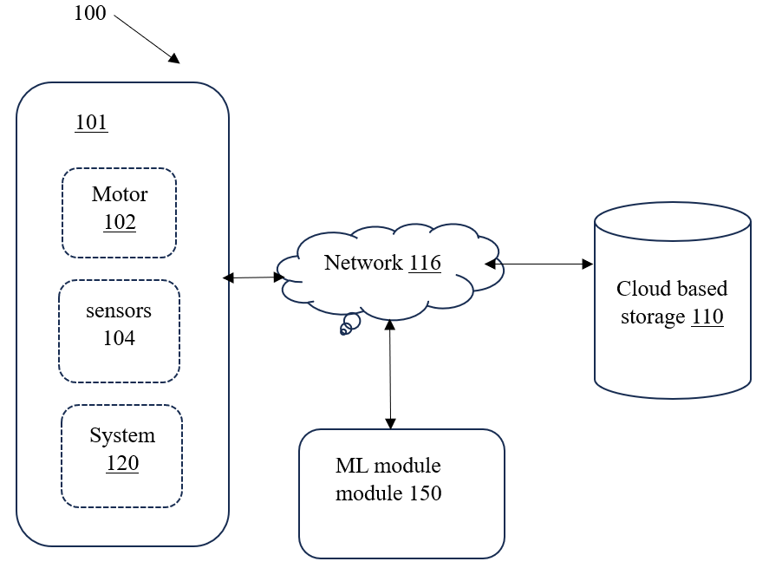

Figure – 1 A

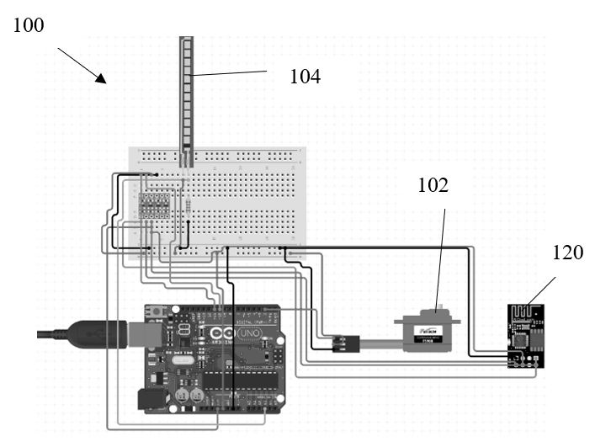
Figure – 1 B

Dated this – 26/12/2024
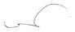

Vikas Asawat
Patent Agent & Advocate
INPA 1407
On Behalf of Applicant
Digitally Signed

Applicants: Dr. Chiranjit Sain, Dr. Amarjit Roy, Total Sheets 8
Nayan Nirban Baruah, Rituraj Boruah, Ujjal Ray Sheet 2 of 8

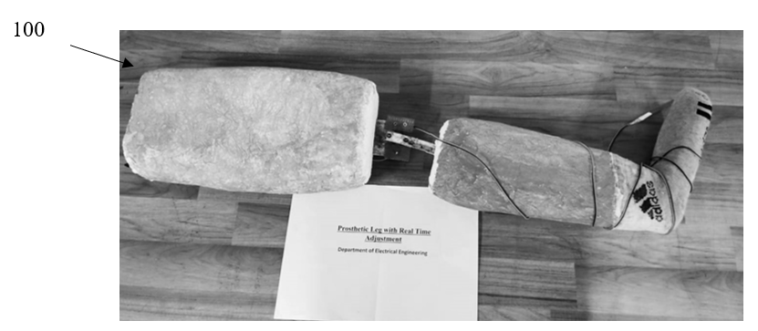

Figure – 2 A

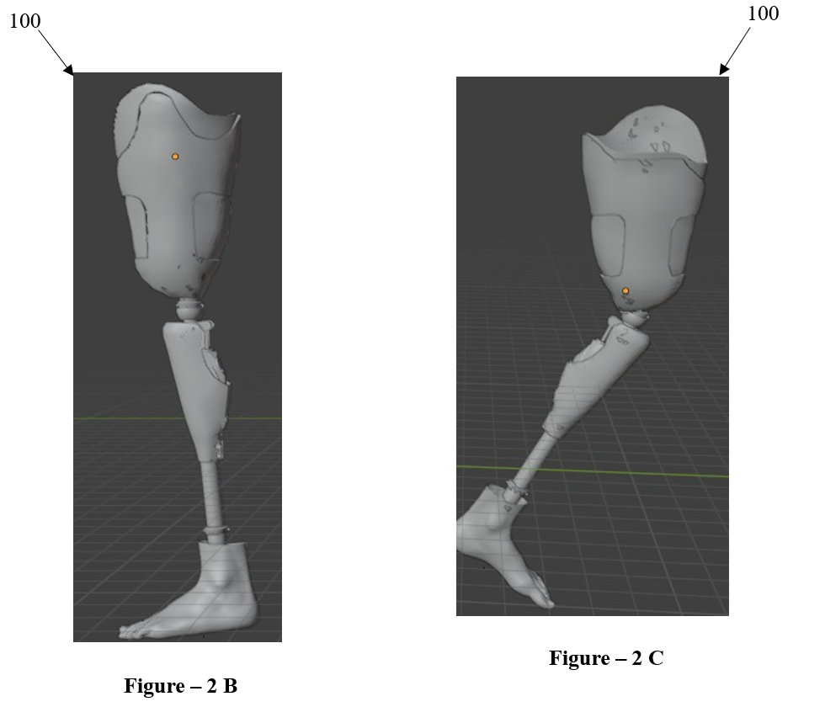

Dated this – 26/12/2024


Vikas Asawat
Patent Agent & Advocate
INPA 1407
On Behalf of Applicant
Digitally Signed
Applicants: Dr. Chiranjit Sain, Dr. Amarjit Roy, Total Sheets 8
Nayan Nirban Baruah, Rituraj Boruah, Ujjal Ray Sheet 3 of 8

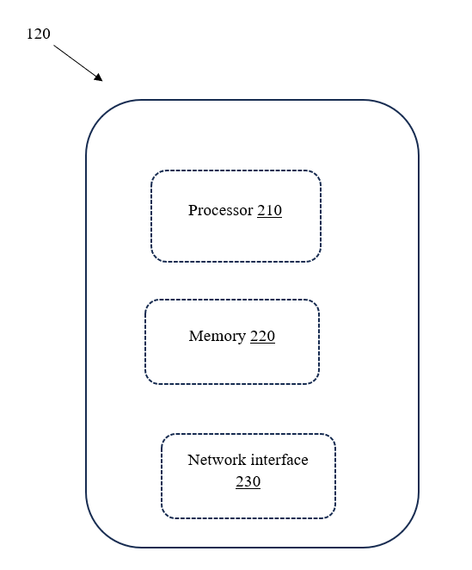

Figure – 3

Dated this – 26/12/2024


Vikas Asawat
Patent Agent & Advocate
INPA 1407
On Behalf of Applicant
Digitally Signed

Applicants: Dr. Chiranjit Sain, Dr. Amarjit Roy, Total Sheets 8
Nayan Nirban Baruah, Rituraj Boruah, Ujjal Ray Sheet 4 of 8

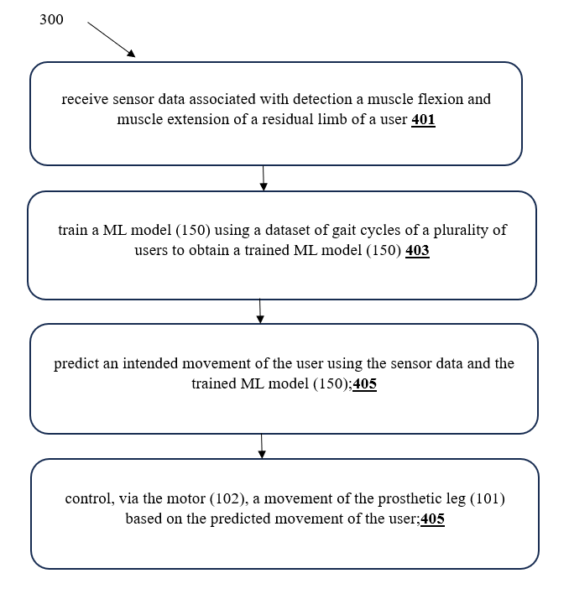

Figure – 4

Dated this – 26/12/2024


Vikas Asawat
Patent Agent & Advocate
INPA 1407
On Behalf of Applicant
Digitally Signed

Applicants: Dr. Chiranjit Sain, Dr. Amarjit Roy, Total Sheets 8
Nayan Nirban Baruah, Rituraj Boruah, Ujjal Ray Sheet 5 of 8

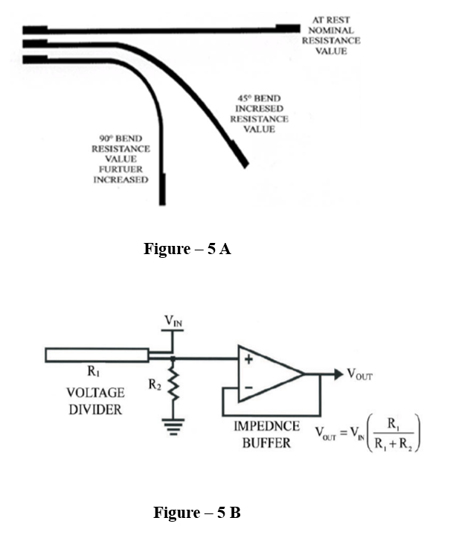

Dated this – 26/12/2024


Vikas Asawat
Patent Agent & Advocate
INPA 1407
On Behalf of Applicant
Digitally Signed

Applicants: Dr. Chiranjit Sain, Dr. Amarjit Roy, Total Sheets 8
Nayan Nirban Baruah, Rituraj Boruah, Ujjal Ray Sheet 6 of 8

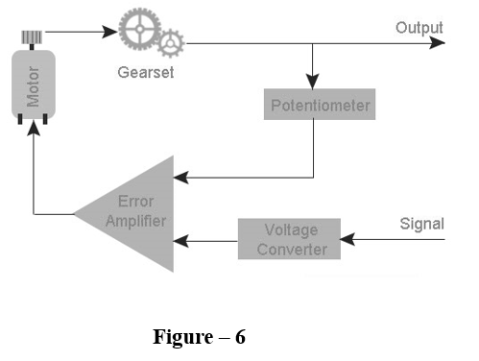

Dated this – 26/12/2024



Vikas Asawat
Patent Agent & Advocate
INPA 1407
On Behalf of Applicant
Digitally Signed

Applicants: Dr. Chiranjit Sain, Dr. Amarjit Roy, Total Sheets 8
Nayan Nirban Baruah, Rituraj Boruah, Ujjal Ray Sheet 7 of 8

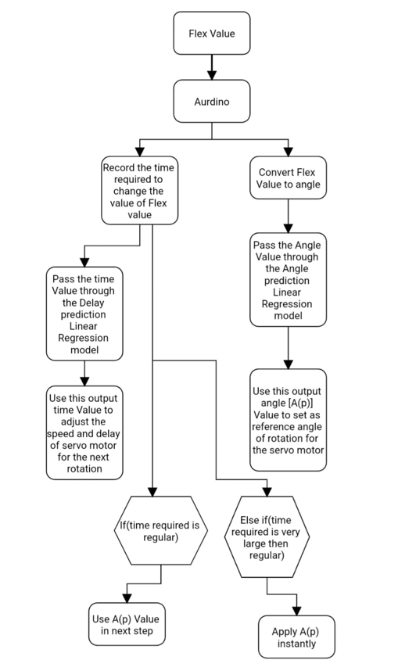

Figure – 7
Dated this – 26/12/2024


Vikas Asawat
Patent Agent & Advocate
INPA 1407
On Behalf of Applicant
Digitally Signed

Applicants: Dr. Chiranjit Sain, Dr. Amarjit Roy, Total Sheets 8
Nayan Nirban Baruah, Rituraj Boruah, Ujjal Ray Sheet 8 of 8

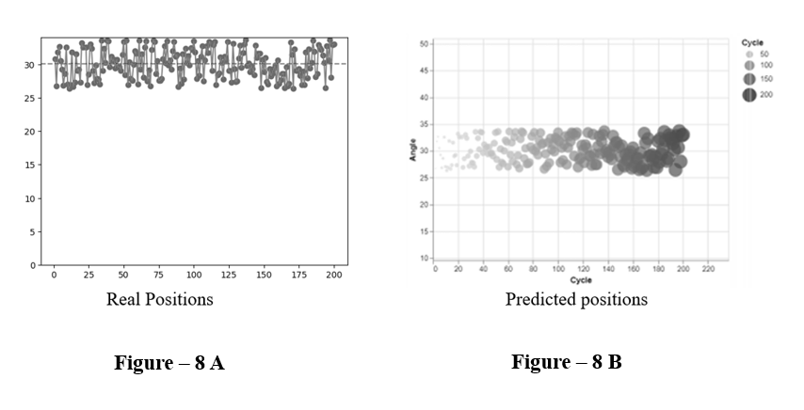

Dated this – 26/12/2024



Vikas Asawat
Patent Agent & Advocate
INPA 1407
On Behalf of Applicant
Digitally Signed

